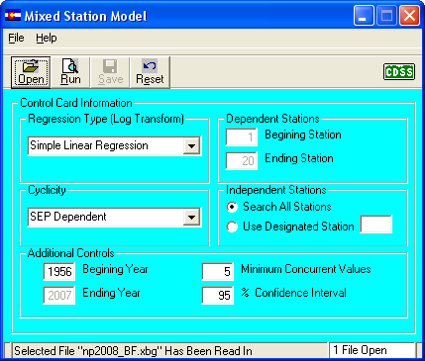

Reads in the \*.xbg file (unfilled baseflows at gaged locations)

Performs the MSM filling analysis using the parameters set above

Outputs:

* \*.xbf, time series, filled baseflows at gaged locations
* \*.sts, statistics summary
* \*.sum, filing summary (correlation coefficients)
* \*.xbf-1, time series, filled baseflows at gaged locations if averages were needed

Note that I believe the data included in the North Park sample was all filled using the regression data, therefore the \*.xbf and the \*.xbf-1 are identical.